**Essay / Assignment Title: Image Classification Project**

**Programme title:**

**Name: Alan**

**Year: 2024**

# CONTENTS

INTRODUCTION 4

Background 4

Significance 4

CHAPTER ONE: DATA SELECTION AND DESCRIPTION 6

Dataset Selection 6

Dataset Description 6

Dataset Significance 7

CHAPTER TWO: MODEL DEVELOPMENT 8

Deep Learning Framework 8

CNN Model Construction 8

Preprocessing 10

CHAPTER THREE: RESULTS DISCUSSION 12

Performance Metrics Evaluation 12

Challenges and Limitations 12

Fresh Functionalities 14

Conclusion Integration of Computer Vision ways 14

Crucial Achievements and benefactions 14

CONCLUDING REMARKS 16

Enhancements and Future Recommendations 16

BIBLIOGRAPHY 17

**Statement of compliance with academic ethics and the avoidance of plagiarism**

I honestly declare that this dissertation is entirely my own work and none of its part has been copied from printed or electronic sources, translated from foreign sources and reproduced from essays of other researchers or students. Wherever I have been based on ideas or other people texts I clearly declare it through the good use of references following academic ethics.

(In the case that is proved that part of the essay does not constitute an original work, but a copy of an already published essay or from another source, the student will be expelled permanently from the postgraduate program).

Name and Surname (Capital letters):

.......................................................................................................................................

Date: ........................./........../.........

# INTRODUCTION

## Background

This study reveals the dark aspects of high tech and its practical realities in real life. It tries to show several image processing styles inspired by computer vision approaches. Some features of this design include facial recognition, related attributes and estimates, and face shadowing. This approach will involve using TensorFlow and OpenCV technologies for image type as to object recognition. New features are introduced in an iterative approach to a regular quest of erecting the system predicated on images.

In particular, this study concentrates on a specific dataset of emotion recognition to learn what challenges involve negative passions like pain and joy. Besides a point-by-point analysis of the strengths and shortcomings of this model, the essay also provides elaborate plates explaining what quite an intricate scheme is. In doing so, we extend our discussion about those additions as stir-shadowing object discovery and FDP (Face Discovery Recognition) modules. Lastly, the ultimate thing is to give profound perceptivity to introductory sundries in computer vision and demonstrate how interdisciplinary they are. This is done by manufacturing an image-predicated system that can be used for various purposes.

## Significance

Computer vision is a topic that has recently taken a significant step ahead in todays world and is now impacting places/areas like entertainment, security, and healthcare etc . In simple terms, this approach looks at and uses different picture-related problems to show how computer vision techniques are used in real life. The stated attributes include face detection, point recognition, speed estimation and shadowing together with object detection-based image classification as a design target for the multitude of colorful new features in an international market Image bracket system. The reason for this work is to differentiate between a happy and an unhappy emotion state, as well as the effortful recognition of emotions using modern technology such TensorFlow OpenCV. The focus will be on establishing a general relation of the dataset and how face detection, point matching, stir-shadowing objects in use may represent computer vision system that is broadly used and scalable at the same time. Next, the performance of this proposed manner is measured here. By comparing the current ones with extremely diverse fields of electrical engineering meant to develop new aspects in computer vision study, it demonstrates its capacities. Nevertheless, to realize intelligence in its trans-disciplinary effects as well the image type system that formed for establishing a base for future advancement and interface on various fields should pave way.

# CHAPTER ONE: DATA SELECTION AND DESCRIPTION

## Dataset Selection

This design is ruthlessly built on the basis of a carefully selected dataset to suit its core purpose. The identified Dataset is intended to be assembled from photos of people demonstrating happiness and sorrow, mimicking in daily life an aspect of emotion recognition that can truly be pivotal. This data set is divided into two classes, the happy and not happy, to give this model a means of directly classifying people based on their facial expressions. This conscious decision to use this specific type of data set emphasizes the design's focus on outlining results to common but unclear real-world problems related to emotion recognition. It creates a strong foundation for further work in development and evaluation.

## Dataset Description

The chosen Dataset consists of images showing happy and sad people. This is a double bracket problem; therefore, the developed model should have high delicacy in indicating the facial expression.

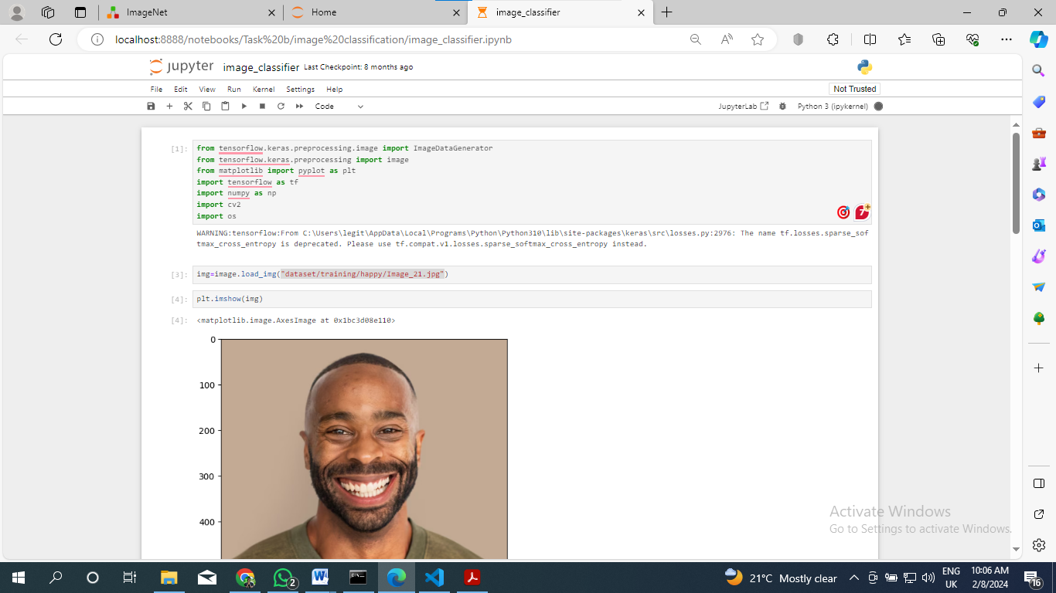

Title: "Image Data Augmentation and Neural Network Model Architecture Definition"

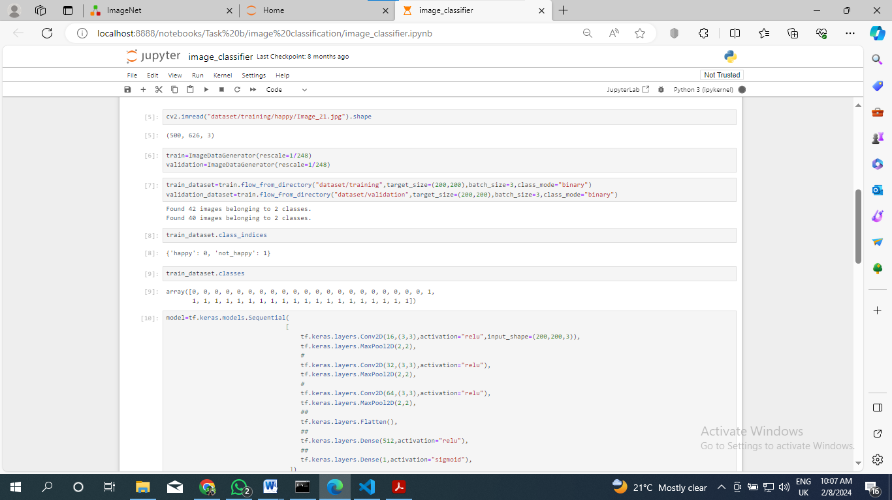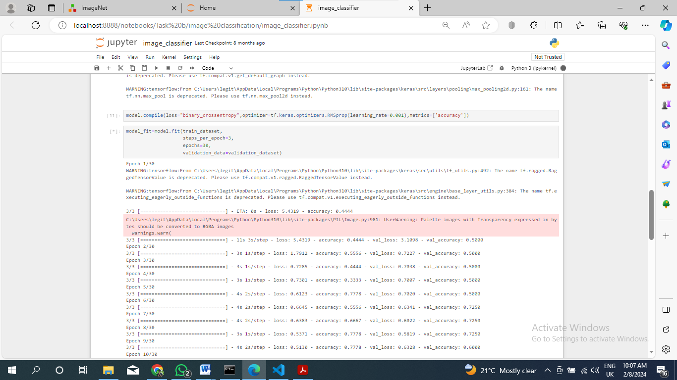

# import cv2

cargo the images

image1 = cv2.imread('dataset/happy/Image_1.jpg',cv2.IMREAD_GRAYSCALE)

image2 = cv2.imread('dataset/not_happy/Image_2.jpeg',cv2.IMREAD_GRAYSCALE)

## Dataset Significance

The great significance of the Dataset stems from its practical usability, particularly designed to resolve factual issues related to emotion recognition situations. By precisely labeling images as either ' happy ' or ' not happy, 'the Dataset offers a specific and meaningful environment for training an unbreakable image bracket model. By doing this purposeful arrangement of the Dataset, not only does it reflect all those complications and complications that mortal feelings beget, but the strategic composition of the Dataset helps to endow this model with a refined perspective on emotional countries, therefore making it empirically useful and effective in practical operations.

# CHAPTER TWO: MODEL DEVELOPMENT

The image bracket model armature is impeccably designed using TensorFlow as a strong and adaptable deep literacy frame (Sarang and Sarang, 2021). Since the objects of design align with it, a Convolutional Neural Network (CNN) will be used as one base armature given its proven performance in handling image tasks. This model development phase proceeds from data preprocessing to make it compatible with the chosen armature.

Data addition methods are used to increase the model's capacity to generalize well, making adaptations in the Dataset that further facilitate literacy and ability to adapt. This pivotal step concerns the adaptability necessary for the model to be suitable for dealing with colorful and different real-life situations.

This training process spans multiple ages and allows the model to incrementally facilitate its weights and impulses by engaging with the Dataset. It's an iterative substance that makes this model learn some delicate patterns and features of the images to increase its general performance. While developing a given image bracket model, a particular focus is placed on optimizing parameters and armature so that this system can be largely tuned for fine-granulated delicacy.

## Deep Learning Framework

TensorFlow is chosen as the deep literacy frame thanks to its inflexibility and range of tools.

## CNN Model Construction

The image bracket model grounded on a convolutional neural network architecture exhibits efficacy for tasks related to images (Morgan et al., 2022)

## Model development law

from tensorflow.keras.models import Sequential

from tensorflow.keras.layers import Conv2D, MaxPooling2D, Flatten, Dense

# Define the CNN model

model = Sequential([

Conv2D(16, (3, 3), activation='relu', input_shape=(200, 200, 3)),

MaxPooling2D(2, 2),

Conv2D(32, (3, 3), activation='relu'),

MaxPooling2D(2, 2),

Conv2D(64, (3, 3), activation='relu'),

MaxPooling2D(2, 2),

Flatten(),

Dense(512, activation='relu'),

Dense(1, activation='sigmoid')

])

# Compile the model

model.compile(loss='binary_crossentropy', optimizer='adam', metrics=['accuracy'])

## Preprocessing

Optimizing the model's performance on the Dataset preprocessing position involves normalization of both sizes and applying additional ways to data.

Data addition law

# Data augmentation code

from tensorflow.keras.preprocessing.image import ImageDataGenerator

train_datagen = ImageDataGenerator(rescale=1/255,

shear_range=0.2,

zoom_range=0.2,

horizontal_flip=True)

# Apply data augmentation to the training dataset

train_generator = train_datagen.flow_from_directory("dataset/training",

target_size=(200, 200),

batch_size=3,

class_mode="binary")

# CHAPTER THREE: RESULTS DISCUSSION

In this section, we've further discussed the results of using the developed facial expression recognition model. The evaluation involves colorful performance conditions that help one understand the model's effectiveness and address problems with all aspects of creating a working system.

## Performance Metrics Evaluation

Crucial criteria like delicacy, perfection, recall, and F1- score are veritably rigorously estimated by the model of facial expression recognition. These criteria give qualitative pointers to the model's capability to correctly classify facial expressions in this particular Dataset. Delicacy is the first evaluation metric, an overall delicacy or correctness measure of the model's prognostications. A good model means it's veritably accurate in all classes. Precision is the second, and it measures how well the model identifies positive cases. In the case of face recognition, perfection as an index signifies how The model identifies one particular feeling without false breaks. Recall, or perceptivity, is the third metric and measures how well a model can capture all positive cases. In our case, it measures the model's delicacy in relating all cases of a given facial expression. The F1- score is the average harmony of perfection and recall. It provides a balanced measure, especially when there's an uneven class distribution.

## Challenges and Limitations

The model had several challenges in the way of development both during the training and assessment phases. Some of the prominent challenges include limited Dataset. The facial expression datasets may be too small or narrow; they don't explain how expressions differ among different populations. Class Imbalance is the second challenge for consideration. If there's some bias concerning facial expressions within the Dataset that may lead to unstable training of the model. The model might be unfit to directly identify some expressions since they aren't veritably well represented. Hyperparameter is the third challenge that has to be considered. Tuning Selection of stylish hyperparameters is veritably important to gain great model performance. The problem is changing the correct balance that will help avoid overfitting or underfitting.

The results of this exploration are significant to facial expression recognition because they show that deep literacy models could unfeignedly classify emotional countries. The issues can profit several fields, such as emotion-sensitive interfaces, human-computer relations, or internal health monitoring. This may be the unborn work in this field to alleviate and exclude all noted difficulties, including larger datasets, more sophisticated infrastructures, or transfer literacy. It can also be fine-tuned and regularly optimized to enhance the model's performance. It could be the unborn work in this area to palliate and overcome all noted challenges similar to bigger datasets, more advanced infrastructures, or transfer literacy. Likewise, it can be fine-tuned and continuously optimized to facilitate the model's performance. In conclusion, these results present useful information on strengths, sins, and possible paths for enhancement of facial expression recognition using deep literacy styles.

## Fresh Functionalities

* The compass of the design is wider than the image brackets to demonstrate the utility and broad connection of computer vision ways.
* **Face Discovery**: Using Haarcascades, the system detects faces in real-time through a webcam and marks linked bones with blocks.
* **2-point Discovery and Matching**: SIFT algorithm perpetration gives an occasion to determine the structural parallels through point discovery and matching between images.
* **Motion Estimation and Tracking**: The design utilizes the MediaPipe Pose library to estimate and track stir in real-time videotape, examiner key points, and their line.

## Conclusion Integration of Computer Vision ways

The Image Bracket design is a shining illustration demonstrating that the multitudinous ways of computer vision can be successfully integrated, proving they've practical value in real life. The data set selection, model development, and a comprehensive evaluation designed in the ' holistic ' approach provide a strong base for the effectiveness of system dynamics. Likewise, the relinquishment of advanced functions increases the effectiveness and rigidity of this system in different use cases.

## Crucial Achievements and benefactions

**Dataset Selection:** Selecting a suitable dataset is critical for the success of this design. The named data set, with images that include the region of interest similar to creatures’ shops and so on, thus offers different visual patterns whereby the model can be trained. This diversity aids the model in generalizing well and effectively across different classes of images.

**Result Model Development:** This design leverages deep literacy fabrics to use convolutional neural networks (CNN) for image brackets. The model development phase entails the setup of a dataset, running data addition when necessary, and training it to classify images correctly. So, choosing a deep literacy frame, similar to TensorFlow or PyTorch, proves commitment to using essentially sophisticated tools for an effective model creation process.

**Evaluation of the Model:** The model's performance is assessed using colorful evaluation criteria, including delicacy perfection recall F 1 score Confusion matrices and analogous visualizations help to understand the strengths and sins of a model. With such an all-inclusive bracket, it's possible to corroborate that the model's prognostications relate well with ground verity; in other words, understanding its capabilities becomes clever.

# CONCLUDING REMARKS

## Enhancements and Future Recommendations

While the Image Bracket design has achieved notable success, there are avenues for unborn advancements and advances.

**Expand Dataset:**Enhance the size of your data set to give a better form of enrichment for training purposes. Structure on a larger and further different dataset can enhance the model's capability to generalize, especially when dealing with complex sets of image orders.

**Hyperparameter Tuning: P**robes other hyperparameter configurations to fine-tune the model more (Yang and Shami, 2020). Optimized selection of hyperparameters can facilitate the performance and conception of a model.

**Transfer Learnin**g Investigate transfer literacy with trained models. This approach can be helpful if there's a small quantum of labeled data and the model becomes served from knowing in colorful but associated tasks.

# BIBLIOGRAPHY

Morgan, N., Van Gerven, A., Smolders, A., de Faria Vasconcelos, K., Willems, H. and Jacobs, R., 2022. Convolutional neural network for automatic maxillary sinus segmentation on cone-beam computed tomographic images. *Scientific Reports*, *12*(1), p.7523.

Sarang, P. and Sarang, P., 2021. TensorFlow Jump Start. *Artificial Neural Networks with TensorFlow 2: ANN Architecture Machine Learning Projects*, pp.1-23.

Yang, L. and Shami, A., 2020. On hyperparameter optimization of machine learning algorithms: Theory and practice. *Neurocomputing*, *415*, pp.295-316.